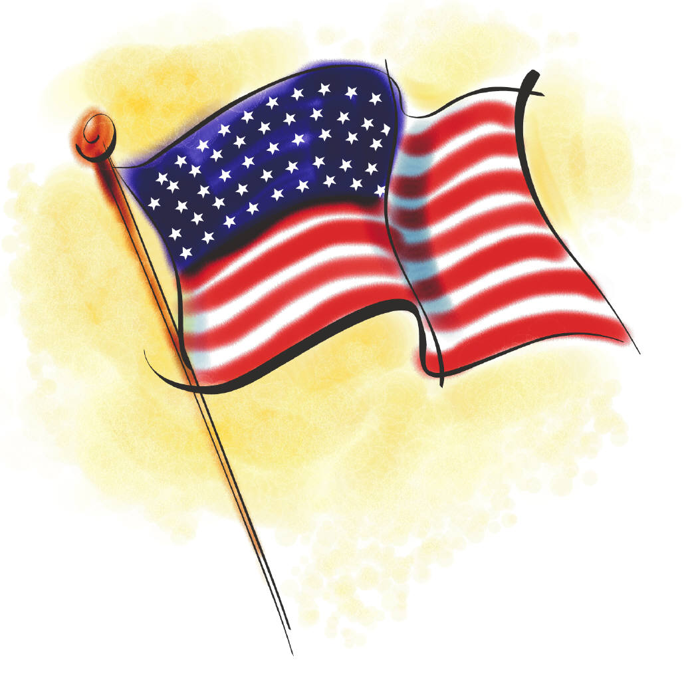

Independence Day Celebration
Downtown Parade on July 4th

The Huron Chamber & Visitors Bureau would like to invite you to participate.
July 4th promises to be fun with a parade, flea market, and BBQ!

Official Entry Form
Parade Line Up: 10:00 am
Parade: 10:30 am
Line up will be at Huron Arena, 5th and Illinois, head down to 7th street. Chamber staff will be assisting with line up. The parade will then proceed to Dakota Avenue, then North to Market Street, then West to Illinois Avenue.

Name of Entry: ______________________________________
Contact Person: _____________________________________
Mailing Address: ____________________________________
Email: _____________________________________________
Description of Entry: _________________________________
____________________________________________________
Return the completed entry form and the $5 entry fee to:
Huron Chamber & Visitors Bureau
1725 Dakota Ave. S.
Huron, SD 57350

For more information, call (605) 352-0000 or 1-800-487-6673
Email: cvb@huronsd.com

Independence Day Celebration
Vendor Fair & Parade
July 4th, 2025

Hold Harmless Agreement

I, __________________________________, city of Huron, State of South Dakota, for myself and my heirs, legal representatives and assigns, in consideration of the sum of One Dollar (included in parade entry fee), and other good and valuable consideration to me paid to the Huron Chamber & Visitors Bureau, receipt of which is hereby acknowledged. Agreement with said Huron Chamber & Visitors Bureau of 1725 Dakota Ave. S., City of Huron, County of Beadle, State of South Dakota, its heirs, legal representatives and assigns, to never institute, prosecute or in any way aid in the institution or prosecution of any claim, demand, action, or cause of action for damages, costs, loss of services, expenses, or compensation for or on account of any damage, loss or injury either of person or property, or both, whether developed or undeveloped, resulting or to result, known or unknown, past, present or future, arising out of:

Independence Day Celebration
Vendor Fair & Parade
July 4, 2025

In executing this agreement, I expressly reserve any and all right, causes of action, claims and demands against any person, firm or corporation including the Huron Chamber & Visitors Bureau.

Executed at Huron, South Dakota, on this ____ day of __________________, 2025.

Print Name: _____________________ Signature: __________________________

By signing this agreement, I understand that I am responsible for maintaining clean up of my float and/or responsible for maintaining the garbage in my area, adhere to the hours of the Vendor Fair and adhere to all items mentioned in the above paragraphs.

