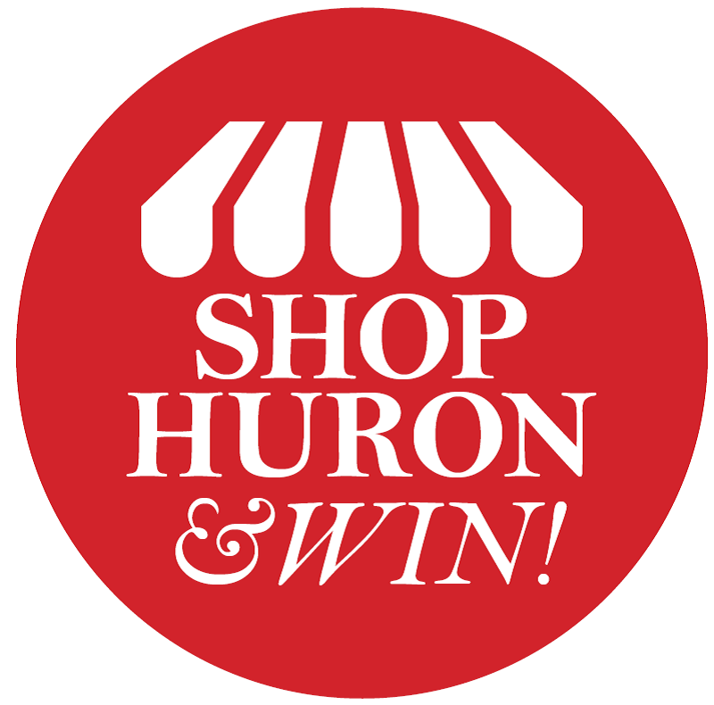
Sleigh the Holidays..
Shop Huron & Win 2024

Terms and Conditions

The campaign will start November 1st and run through December 24th. The theme for the campaign is “Sleigh the Holidays”.
By entering or participating in the Shop Huron & Win promotion, you are agreeing to the following terms:
Eligibility:
The contest is open to all legal residents of the United States. Entrants must be at least 18 years of age. Promotion applies to individuals only (not a business or company).
Employees, board members and families of Huron Chamber & Visitors Bureau are not eligible.
Qualifying Entries:
Purchases made at Huron businesses must be dated November 1–December 24, 2024. One entry for every $25 in purchases (maximum of 20 entries per receipt). Receipts may be combined to reach $25. Double Entries for purchases made at chamber member businesses. Loan payments or utility payments excluded. Entries will be submitted by texting or emailing a clear picture of the receipt(s) along with your name, address and phone number to (605) 354-5307 or cvb@huronsd.com. If you are unable to text or email your receipt, you may bring your receipt the Chamber office at 1725 Dakota Avenue S.
For alternative entry, stop by the Chamber office and complete an entry form or mail a legible letter expressing desire to enter the Shop & Win contest with full name, address, phone number, and email address to Huron Chamber & Visitors Bureau, 1725 Dakota Avenue South, Huron, SD 57350. Must be postmarked between November 1 and December 24, 2024.
All receipts must be submitted by December 27th at 5pm.
Prizes:
The “Sleigh the Holidays” Christmas Campaign will have a grand prize, 2nd place and 3rd place winners. The name drawn for the Grand Prize will receive $1500 in Huron Bucks, the name drawn for the 2nd Place Winner will receive $1000 in Huron Bucks, and the name drawn for 3rd place will receive $500 in Huron Bucks. The drawing will take place on December 30 at 3:00 PM at the Huron Chamber & Visitors Bureau, 1725 Dakota Ave S.
There will also be weekly prizes given that will take place at sponsor businesses. These drawings will be shown live on the Huron Chamber & Visitors Bureau Facebook page.
Odds depend on number of eligible entries received.
Should any winner be unable to accept their prize or be ineligible for some other reason, another drawing will be held from eligible entries received to choose a new winner.
All local, state, federal and other taxes, or other fees for prizes awarded become the sole responsibility of the winner.
All entrants and winners agree to allow photo and name to be used for promotional purposes.
Liability:
All entrants and winners agree that the participating businesses, sponsors and their affiliates shall have no liability and shall be held blameless for any injury, misfortune, or damage to either persons or property incurred by entering, participating in, winning, or losing any contest by use or non-use of any prize received.
Participation in the contest constitutes entrants full and unconditional agreement to and acceptance of these official rules and the decisions of the sponsor, which are final and binding. Winning a prize is contingent upon being compliant with these official rules and fulfilling all other requirements set forth herein.

